Stakeholder Forum | Opinion
The Age of Super Centers: Rethinking Electric Power
The Purpose of the Public Grid is to Service Small Loads
 Listen to this story
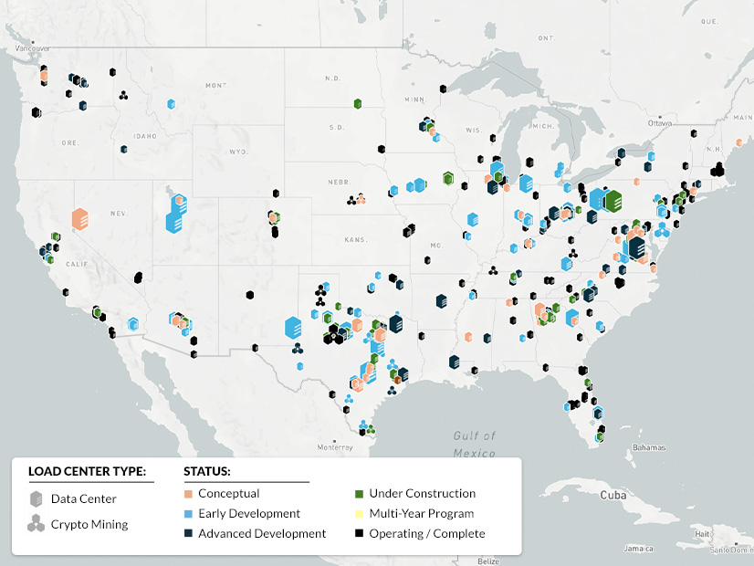
Co-location data centers across the U.S. | Yes Energy
May 26, 2026 | Stakeholder
The U.S. electric power system was not designed for gigawatt-scale customers. Yet that is exactly what data centers and chip foundries are now demanding. As large load demands increase, a central policy question is emerging: whether a single, shared grid can continue to serve all users efficiently, or whether a more differentiated approach is needed.
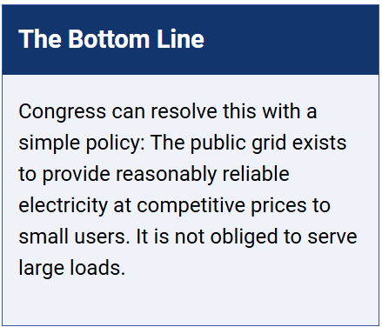
Two Systems, Not One
Large industrial loads and traditional retail customers do not want the same thing. AI data centers and certain industrial processes place a premium on reliability. A moment’s interruption can cost a fortune. Households care primarily about price and can tolerate the occasional inconvenience.
Designing a single system to meet both sets of requirements will introduce tradeoffs. A system optimized for ultra-high reliability will carry higher costs than most customers are willing to bear, while a system optimized for affordability will not meet the performance needs of large industrial users. Trying to serve both needs with a single system is like designing a vehicle that is equally good at hauling freight and running errands. It can be done, but it will not excel at either.
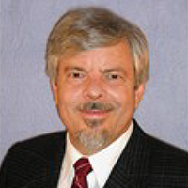
Alex Pavlak
The better approach already is common at a smaller scale. When an industrial load gets big enough, say 100 MW, it generally builds its own power. As large loads climb to thousands of megawatts, that practice will rule. Two different systems are more efficient than a single integrated system.
The public grid would continue to serve distributed customers through a network of generators and transmission infrastructure, optimized for cost and broad accessibility.
Large, privately developed “super centers” will integrate generation, load and cooling on a single site, designed for high reliability and operational control.
We have seen hints of this before. The Tennessee Valley Authority and the Bonneville Power Administration are grand federal entities born of the New Deal. But those are relics, not road maps. The new systems will be private, more common, more specialized.
Data Centers Grow Up
Not long ago, a large data center was about 10 MW. Cloud computing tasks (banking, reservations, streaming … ) could be divided into small pieces and scattered across the grid. Plugging into the public grid made sense.
Artificial intelligence is different. Its computational load is massive and indivisible. Projections are 1,000 MW or more in one place. Plugging that into the public grid is like trying to run a steel mill off a household extension cord.
As data centers grow, they will rediscover an old industrial lesson: If you want true reliability, you build it yourself. The surest path is co-location, placing the data center beside its power source, eliminating transmission losses and its many points of failure, and designing the whole system as a single integrated unit.
Nuclear fission, large, reliable and clean, is attractive, but it takes time to deploy. Natural gas can serve as a bridge, quick to build and flexible, before shifting into a backup role as the super center grows and onsite nuclear capacity expands.
Federal Vision Can Minimize Confusion
Data centers want to plug into the public grid because that is what they have always done and it is cheaper if the small user helps pay for transmission upgrades. Utilities want to serve them. States worry about the small user getting a huge bill. Regulators try to keep all stakeholders happy. (See FERC Directs PJM to Issue Rules for Co-locating Generation and Load.) There is no long-term vision. The result is a fine mess.
Congress can resolve this with a simple policy: the public grid exists to provide reasonably reliable electricity at competitive prices to small users. It is not obliged to serve large loads (say beyond 25 MW) that strain the system. Private super centers could sell excess power to the grid, but they would not load the grid. That clarity alone would reduce today’s confusion and guide investment.
Adaptable States Can Control Transition
First, they will strategically plan where these super centers can be built. Water will be a stubborn constraint. A 10 GW super center could evaporate 40 million cubic feet per day of water for cooling.
Second, they will clear away regulatory thickets that slow development without improving outcomes.
Third, they will help manage the transition, including interim energy solutions, the assembly of sites.
Fourth, they will require developers to play nice with the neighbors and commit to a long-term sustainable power plan.
Alex Pavlak is a Ph.D. engineer and the chair of the Future of Energy Initiative.

