ERCOT is not performing Reliability Adequacy studies.
IEEE Power & Energy Magazine July/August 2022.
Eugene G Preston https://egpreston.com g.preston@ieee.org
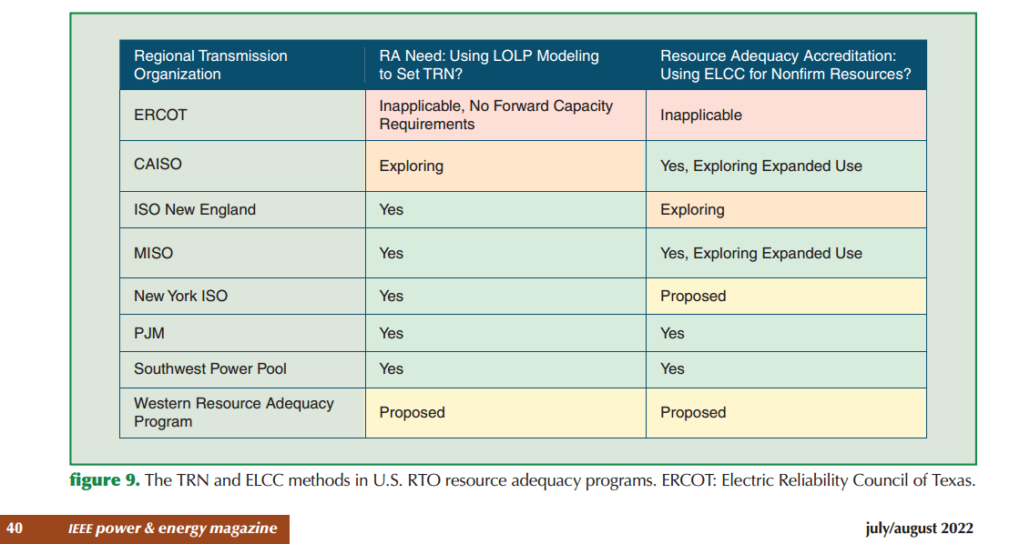

https://www.nerc.com/pa/RAPA/ra/Reliability%20Assessments%20DL/NERC_WRA_2021.pdf
shows ERCOT has -37% reserve margin in a Uri type storm; lowest reliability in the US
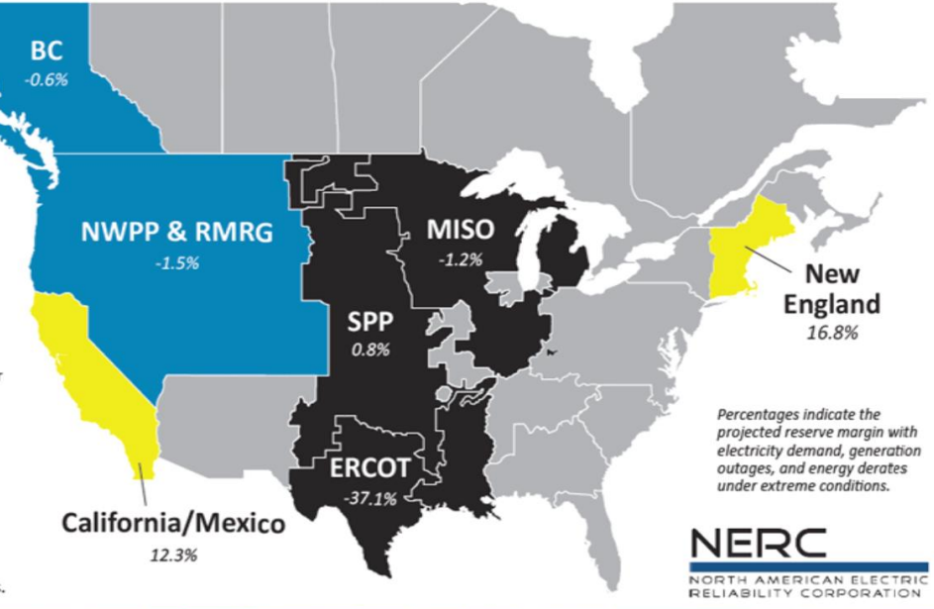

ERCOT Needs These Items to insure Reliability and Prepare for the Future:

- Run Generation and Supply side studies with a wide range of power supply alternatives and perform economic, reliability, and climate change results.

- To insure there is sufficient peaking and black start generation ERCOT determines how much capacity is needed and goes out for bids on this emergency generation capacity. Costs will be uplifted and these generators will not interfere with the market until a certain stage of emergency is reached and then they will be called on. Customers will pay annually these costs along with other uplifted costs.

- The Uri type storm reliability still remains unsolved due to gas supply uncertainties. As a part of item 2 ERCOT should go out for bids for those black start generators to also include oil burning capability and offer this as a separate one time bid item to existing gas generators. The oil backup only needs to be large enough to keep the plant running until either the gas is restored or oil tanker trucks can deliver new oil to those sites if the real time need arises. *

* #3 is not reliable because of icy roads the oil trucks would have to drive on.

