Today I did a 240 VAC test using the 120 VAC extension cord, and plugged into the drier outlet 240 volts.
We don’t use 240 volts on the drier since it’s a gas drier. My wife has a 220 volt steam iron from Europe.
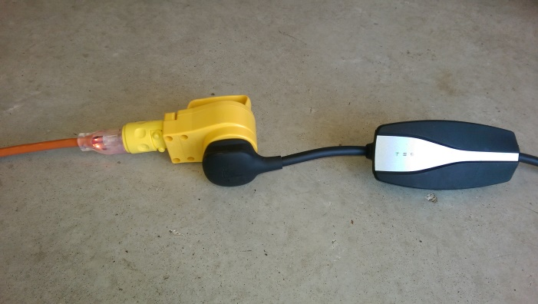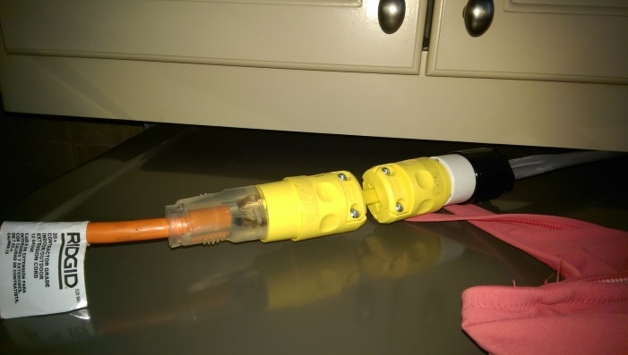
At 20 amps the cord and plugs remained cool except the little neon light was energized at 240 VAC and got warm being designed for 120 VAC. I expect the bulb to burn out soon. The clear plug allows me to inspect the electrical connections for any damage such as melting or arcing. The non-bulb plug was cool.
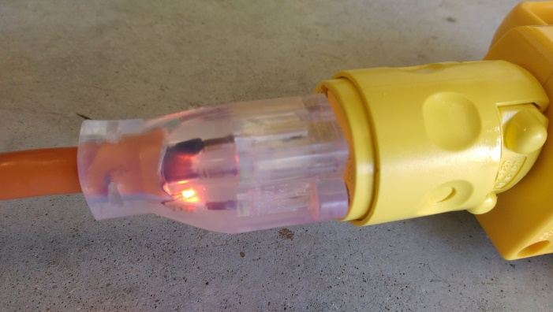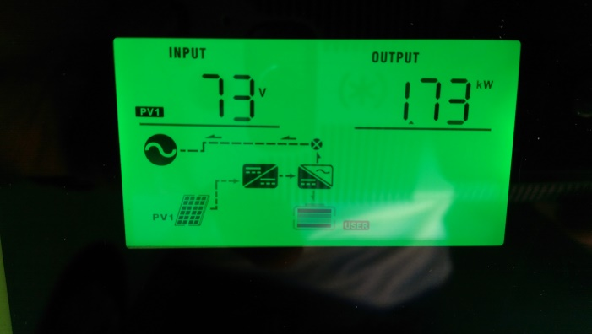
My solar panels were putting out 1.7 kW which is about 7 amps at 240 volts. The charge time is 19 hours. Increasing the current to 20 amps at 240 volts drops the charge time to 7 hours 20 min. At L1 1500 watts the charge time would have been 22 hours. So the 240 volt charging using the 120 VAC extension cord is 3 times faster than at 120 volts. At a destination this makes overnight full charge feasible whereas L1 is not feasible at destination overnight. If you can find a 240 volt outlet use it.
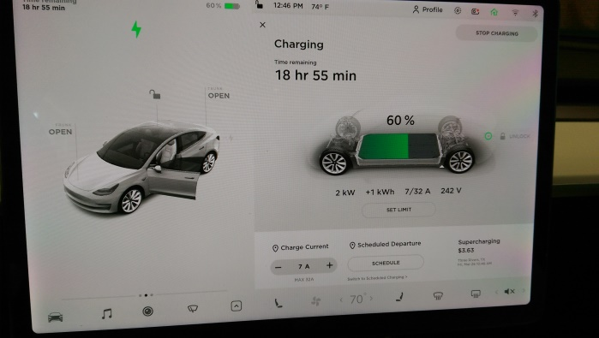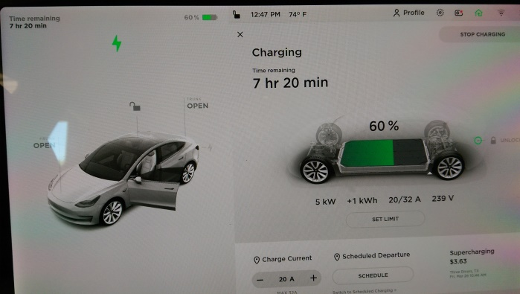

On the left is a 4 pin 30 amp plug. The second one it the 14-50 plug rated at 50 amps but we have to dial back to 20 amps with this setup. Of course I set my Tesla to charge only at 20 amps when using any of these conversion plugs. At that current I should never overload any 240 volt outlet since the minimum should be 30 amps. There is a twist lock plug fits that fits my 240 volt outlet in my cabana powering a smoker. I wonder why they put a twist lock plug on a smoker? The next one is the European 220 volt plug and is rated at 20 amps and can be purchased at Home Depot. Odd a European plug is in our stores. Then there is the receptacle for the 14-50 Tesla plug and mobile charger. The three plugs on the right are different versions of 3 pin 240 VAC plugs used more in the past. The first one is a 50 amp three pin plug. The next one is a 30 amp three pin plug and this is the one used in driers. My daughter uses this plug but I only will draw 20 amps from the outlet at her house. Her wiring is suspect. The last 3 pin plug is an older version and I’m told you may find it in use in some state and national parks. Of course I can always use the 120 volt extension cord at 120 volts if that’s the only outlet I can find.
